Use PowerShell and Wireshark on MAC OS and Linux

You have two options to set your computer. The first one is Virtual Machine which you install Windows 10 and Wireshark. Second, you can install Wireshark and PowerShell on your MacOS or Linux OS computer. It’s up to you to choose one of the options.

In the end, I put some equivalent commands list between Windows and MacOS or Linux.

# Virtual Machine

1. You need to install a virtual machine such as VMWare (free for the students) or Oracle Virtual Box.
   1. VMWare (Windows and MacOS:
      1. Please open to the following link:

<https://e5.onthehub.com/WebStore/Welcome.aspx?ws=3b723f4e-044c-e511-9417-b8ca3a5db7b1>

* + 1. After authentication, you will see the following applications for download:

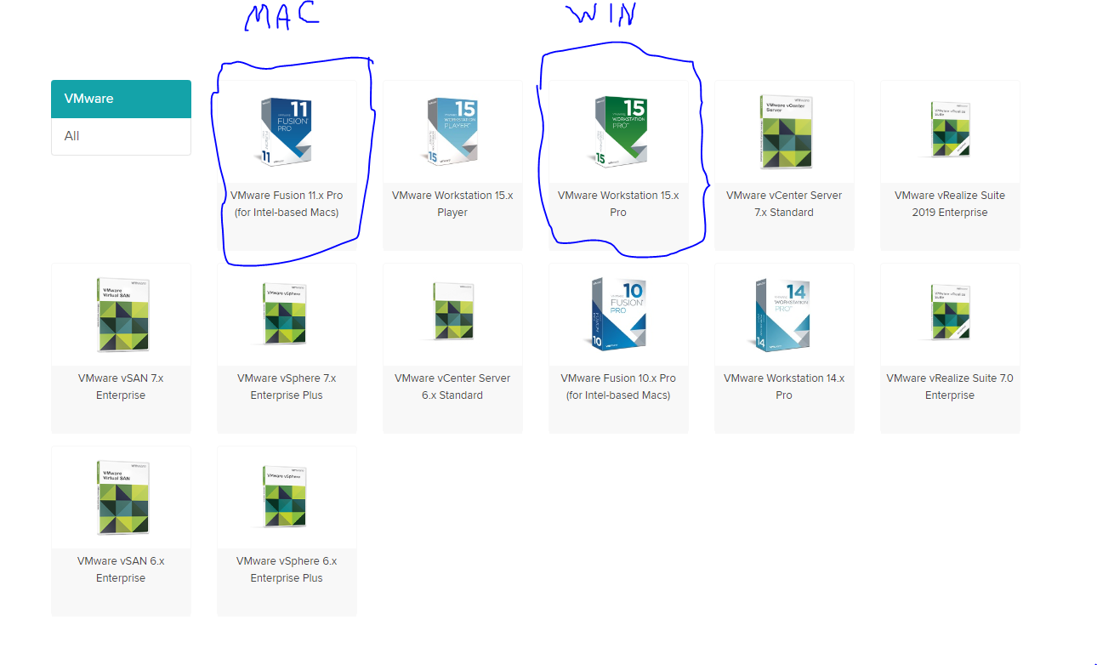

* 1. VirtualBox (for Windows, MacOS, and Linux)
     1. Please open the following link:

<https://www.virtualbox.org/wiki/Downloads>

Then you need to download Windows 10 (4.31 GB) for 90 days training (you don’t need licence) from the following link:

<https://seneca-my.sharepoint.com/:u:/g/personal/majid_shahravan_senecacollege_ca/EXKoVsVGVZtKngEQHRH1nfMBGW11G972ufLu2InfVXsFTA?e=hafUwv>

1. Then you can install Wireshark. Check the link:

<https://www.wireshark.org/download.html>

1. PowerShell:
   1. You don’t need to install anything. It has PowerShell.

# Install Wireshark and PowerShell on MacOS

1. Wireshark:
   1. It’s same as windows and just open the following link:

<https://www.wireshark.org/download.html>

1. PowerShell
   1. It’s a little confusing but it will work
      1. The following link is Microsoft documentation for how to install PowerShell on MacOS:

<https://docs.microsoft.com/en-us/powershell/scripting/install/installing-powershell-core-on-macos?view=powershell-7>

* + 1. Or watch the following YouTube video:

<https://www.youtube.com/watch?v=QBfuzwYUxl8>

# Install Wireshark and PowerShell on Linux

1. Wireshark
   1. Open the terminal on your Linux machine and type the following command (all lowercase):
      1. sudo apt install Wireshark
      2. It will ask you to type your password. After installation, don’t run it by clicking on the Wireshark icon (unless you logged in as root account)
      3. For running Wireshark please type the following command (all lowercase):

sudo Wireshark

1. PowerShell
   1. You need to open the following webpage:

<https://docs.microsoft.com/en-us/powershell/scripting/install/installing-powershell-core-on-linux?view=powershell-7>

* 1. I already test it on Ubuntu 18.04 and it worked fine:

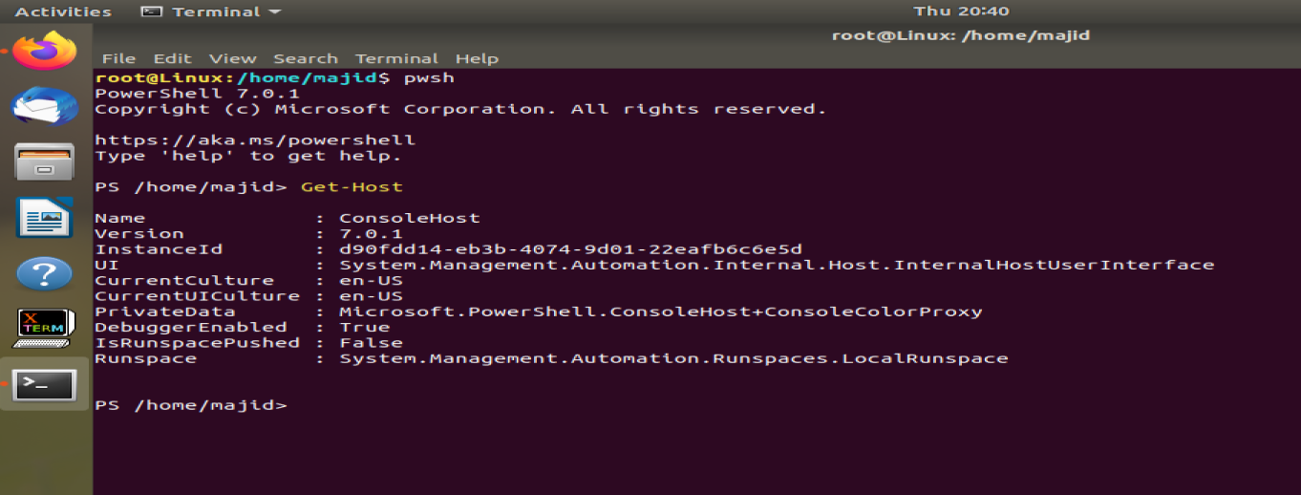

Some equivalent commands from Windows to MacOS and Linux

Because MacOC base on Unix so the commands can be same as Linux:

|  |  |
| --- | --- |
| Windows (CMD commands) | MacOS (Terminal), Linux (Terminal) |
| ipconfig | ifconfig or ip address |
| tracert | traceroute |
| arp -a | arp -n |
| netsh interface ip delete arpcache | sudo ip -s neigh flush all |